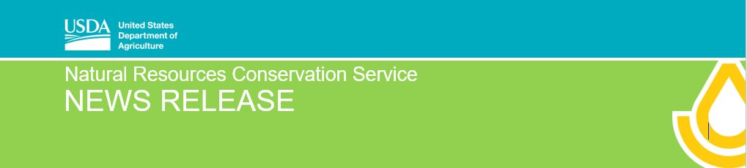
For immediate release: February 20, 2020 Contact: Paige.buck@usda.gov 217-353-6606

Illinois EQIP Application Deadlines Set

Champaign, IL, February 20, 2020 – Look to the USDA-Natural Resources Conservation Service (NRCS) for conservation assistance on agricultural and forestland. Ivan Dozier, Illinois NRCS State Conservationist explains, “NRCS has a long history of conservation planning with agricultural producers and forestry managers. We have the technical knowledge to develop a conservation plan for your resource concerns and NRCS has conservation programs that are available to implement that plan.”

The primary financial assistance program is the Environmental Quality Incentives Program (EQIP). EQIP provides financial and technical assistance to agricultural and forestland producers. To participate, producers can apply for EQIP throughout the year; however, Illinois NRCS has established two application deadlines for March 20, 2020 and April 17, 2020. Producers are encouraged to submit applications by one of the application deadlines if they are interested in the program.

With EQIP, producers can successfully address natural resource issues on their farm. Some EQIP activities include installing structures to address gully erosion, improving pastureland diversity by inter-seeding, and improving soil health by increasing organic matter with cover crops. In addition to conservation practices, EQIP funds the development of a plan, such as Comprehensive Nutrient Management Plans (CNMPs), Grazing Plans, Drainage Water Management Plans, and more.

Producers interested in EQIP should submit a signed application (NRCS-CPA-1200 form) to their local NRCS field office. Applications submitted by March 20, 2020 and April 17, 2020 will be evaluated by NRCS staff for the funding period submitted.

Applicants must meet program eligibility requirements to participate in EQIP. Local NRCS field office staff will work with applicants to assess the land and answer ranking questions. If an application is ranked high enough to be funded, the NRCS staff will work with the applicant to develop a contract.

EQIP is a voluntary conservation program available for agricultural producers and forestry producers. Through EQIP, NRCS will provide financial and technical assistance to install conservation practices. For information on EQIP, contact the local NRCS field office or visit
www.nrcs.usda.gov/wps/portal/nrcs/il/programs/financial/eqip/

###

USDA is an equal opportunity provider, employer and lender.

