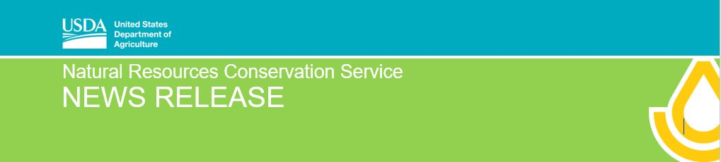
For Immediate Release: April 6, 2020 Contact: Paige.buck@usda.gov 217-353-6606

NRCS Announces Sign-up & Deadlines for Special Conservation Projects

Champaign, IL, April 6, 2020— State Conservationist Ivan Dozier announced that the USDA Natural Resources Conservation Service (NRCS) will be offering special funding for four different projects using the Regional Conservation Partnership Program (RCPP). Producers can apply for assistance through the Conservation Stewardship Program (CSP) which will build on their existing conservation efforts while strengthening their operation through specials enhancements that are offered. Please note that each project is open in specific watershed and counties.

Precision Conservation Management (PCM) is an innovative service program designed to apply financial farm business planning with precision conservation technology to help make intelligent conservation decisions. NRCS has partnered with the Illinois Corn Growers Association to help producers address resource concerns such as water quality and soil health. The NRCS PCM RCPP project will be available to producers whose land is located in the following counties: Champaign, Christian, Douglas, Edgar, Ford, Livingston, Macoupin, McLean, Sangamon, Tazewell, Vermillion, and Woodford.

NRCS has partnered with the Champaign County Soil and Water Conservation District and the Headwaters Invasive Plant Partnership (HIPP) to help producers address resource concerns such as water quality and soil health. The project focus is to reduce soil erosion and improve water quality by improving forest health in the following 11 counties: Champaign, Coles, Cumberland, DeWitt, Douglas, Edgar, Ford, Iroquois, Livingston, Piatt and Vermilion. Financial assistance will be available to producers in east-central Illinois who have land in the above-mentioned counties.

Illinois NRCS will offer funding in Macoupin County for the Upper Macoupin Creek Watershed using the Regional Conservation Partnership Program (RCPP). NRCS has partnered with American Farmland Trust to help local producers address natural resource concerns, namely degraded water quality and soil erosion. The project focus is to improve water quality in the Upper Macoupin Creek Watershed located in portions of Macoupin County. Financial assistance will be available to producers whose land is located in the Upper Macoupin Creek Watershed.

The Mississippi River Basin-Big Bend Enhancing Water-Soil-Habitat Quality project uses the Regional Conservation Partnership Program (RCPP), NRCS, and the Marshall-Putnam Soil and Water Conservation District to help producers address resource concerns such as degraded water quality and soil erosion. The project focus is to improve water quality in Marshall and Putnam Counties.

While applications are accepted throughout the year, interested producers should submit an application to their local NRCS field office by the cutoff date of May 29, 2020, to ensure their applications are considered for 2020 funding. To see if you are eligible to participate in the program, producers should contact their local NRCS field office or visit the Illinois NRCS website at www.il.nrcs.usda.gov. Due to the evolving COVID-19 situation, producers may set up phone appointments with their local NRCS office if they have any questions or need information.

###

USDA is an equal opportunity provider, employer and lender.
NRCS: Helping People Help The Land.

