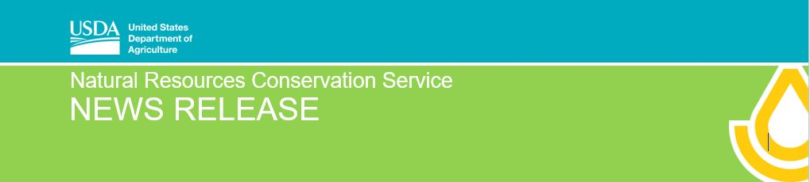
For Immediate Release: September 30, 2020 Contact: Paige.buck@usda.gov 217-353-6606
USDA Awards Nearly $500K to Support Wetland Mitigation Banking in Illinois
Champaign, IL, September 30, 2020 – The U.S. Department of Agriculture’s (USDA) Natural Resources Conservation Service (NRCS) announced it will award $498,010 for a new wetland mitigation banking project in Illinois through the Wetland Mitigation Banking Program. This program helps conservation partners develop and/or establish mitigation banks to help agricultural producers maintain eligibility for USDA programs. “These banks will provide agriculture producers a streamlined mitigation option to remain compliant for USDA Farm Bill programs while maintaining wetlands to support functions and environmental values. Healthy wetlands help filter our water, sequester carbon, curb soil loss, and provide habitat for wildlife,” said Ivan Dozier, Illinois State Conservationist.

The key partner in this Illinois effort is Magnolia Land Partners, LLC. They will establish two agricultural mitigation bank sites totaling 60 acres. Illinois NRCS will provide $498,010 in funding and Magnolia Partners will contribute $252,000. These sites will be added under Magnolia’s NRCS approved statewide agricultural mitigation banking instrument. Magnolia will coordinate the location of the sites with farm groups.

“While 60 acres doesn’t sound like a lot, the environmental benefits and water quality improvements can go a long way, given the relatively small size of wetlands typically converted for farmland,” explains NRCS Assistant State Conservationist for Compliance, Winnie Chen. “All partners involved—as well as new partners to come—see these projects as the start of many new mitigation bank sites that can start impacting Illinois land, water, and soil for years to come,” Chen adds.

Mitigation banks create credits through restoration, creation, or enhancement of wetlands to compensate for impacts on ecosystems in developing communities. Establishing these banks serves Ag producers in more flexible ways. According to Dozier, having Magnolia facilitate and manage all the details for landowners is helpful in what can be a complex legal process. “We’ll keep everyone posted on the site locations and track progress and long-term benefits for the projects,” Dozier adds.

Producers seeking benefits through USDA programs must comply with wetland provisions by avoiding impact on wetlands. In situations where avoidance or on-site mitigation is challenging, the Farm Bill offers participants options to mitigate activities off-site through the purchase of mitigation banking credits.

This competitive grant program helps states, local governments, and other qualified partners develop wetland mitigation banks to assist agricultural producers with meeting wetland conservation compliance requirements to remain eligible for USDA programs. Nationally, USDA will award $5 million for eight wetland mitigation banking projects nationwide. Projects include:

-- CORBLU Ecology Group, LLC in Georgia -- Minnesota Board of Water and Soil Resources
-- EnviroScience in Ohio -- Milton Environmental Consultants in Arkansas
-- Iowa Agricultural Mitigation, Inc. -- Michigan Department of Natural Resources
-- Magnolia and Partners, LLC in Illinois -- South Dakota Farm Bureau

For project descriptions and more information, visit the Wetland Mitigation Banking Program webpage.

USDA is an equal opportunity provider, employer and lender. NRCS: Helping People Help The Land.

