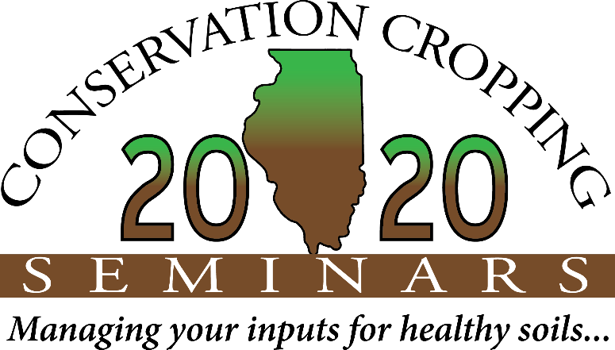 NEWS

_______________________________________________________________________________________________________________________________

For Immediate Release: October 8, 2019 Contact: Paige Buck, NRCS (217) 353-6606

2020 Illinois Seminars Scheduled
Carve out time in your January Calendar now!

October 8, 2019 -- (CHAMPAIGN, IL) – With crazy 2019 weather, planting conditions, and harvest delays, talk about cover crops in Illinois might be at an all-time high. If you haven’t yet got on board with all the sustainable and regenerative changes in agriculture, attending one of the January 21-23 seminars might be just what you need.

Start making plans now to attend one of the 2020 Conservation Cropping Seminar events. Speakers and special guests include Hans Kok, Indiana Soil Health Consultant; Bryan Young, Purdue University Weed and Chemistry professor; and Rick and Aaron Clark, Illinois conservation farmers on the cutting edge of making things do-able and profitable.

According to State Conservationist Ivan Dozier, “These meetings can introduce farmers to the information, the scientific research, and testimonial evidence they need to take steps in transforming their own farm operations. Farmers learn from the speakers at these events, but they also learn from each other as they share successes and lessons learned.” Register early to reserve a spot at the location closest to them: January 21st in Mt. Vernon, January 22nd in Bloomington, or January 23rd in Rochelle, Illinois. Register online at www.ccswcd.com or call the Champaign County Soil and Water Conservation District (SWCD) at (217) 352-3536.

Each seminar costs $20, payable by check or credit card, and it includes lunch. The 2020 events start early and end before 4 pm, with time scheduled during the day to meet and visit speakers, sponsors, or chat with other participants in a small group setting. According to Dozier, Illinois farmers are growing more interested in finding solutions and strategies that can improve success with challenging weather conditions. “I believe more farmers are ready to take steps to make small improvements on their farm that make sense environmentally and economically. “These seminars are the perfect place to begin having those conversations and start making those changes,” Dozier adds.

January 21, 2020 – The Double Tree Hotel – 222 Potomac Blvd. in Mt. Vernon, IL – Contact: Gary (618) 980-0117
January 22, 2020 – The Double Tree Hotel – 10 Brickyard Dr. in Bloomington, IL – Contact: Marty (309) 634-6243
January 23, 2020 – Hickory Grove Conf. Ctr. – 1127 N. 7th St. in Rochelle, IL – Contact: Joe (815) 786-4373

These events offer producers an opportunity to gather facts and make decisions that fit their own operation. To learn more and to register, visit the Champaign County SWCD website www.ccswcd.com. Local businesses and organizations can exhibit, serve as sponsors, and reach local and new clients. See website for details. Primary sponsors and organizers of seminars include Illinois Department of Agriculture, USDA’s Natural Resources Conservation Service, American Farmland Trust, the Illinois Stewardship Alliance, Illinois Environmental Protection Agency, and local Soil and Water Conservation Districts.

