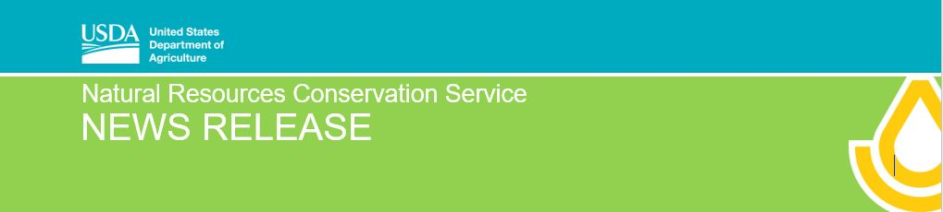
For immediate release: September 12, 2019

Seeking New RCPP Projects for Illinois
Application period has opened for the Regional Conservation Partnership Program

Champaign, IL, SEPT. 12, 2019 – USDA's Natural Resources Conservation Service (NRCS) announced last week the launch of the updated Regional Conservation Partnership Program (RCPP). Potential partners are encouraged to submit proposals that will improve the nation's water quality, combat drought, enhance soil health, support wildlife habitat and protect agricultural viability.

RCPP eligible partners include private industry, non-government organizations, state and local governments, soil and water conservation districts, universities, and more. Partners may request between $250,000 and $10 million in RCPP funding through this funding announcement. Leveraging of this NRCS funding is a key principle of RCPP; partners are expected to make value-added contributions to amplify the impact of RCPP funding.

“The new RCPP offers opportunities for partners and NRCS to develop and implement unique conservation solutions that engage farmers, ranchers and forest landowners,” NRCS Chief Matthew Lohr said. “A single RCPP project can include just about any Farm Bill conservation activity that NRCS is authorized to carry out. We’re really looking forward to what our partners across the Nation propose to do with these new flexibilities.”

State Conservationist Ivan Dozier shares Chief Lohr’s enthusiasm. “We’ve already seen firsthand what RCPP and partners can do here in Illinois. NRCS funds last fiscal year were leveraged with those from Illinois partners for approximately $6.4 million,” Dozier explains. “The goal was to help farmers adopt conservation practices using a targeted approach. The idea of combining federal dollars with private is a game-changer,” Dozier adds.

The first iteration of RCPP, which was created originally by the 2014 Farm Bill, combined nearly $1 billion in NRCS investments with close to $2 billion in non-NRCS dollars to implement conservation practices across the Nation. There are currently 375 active RCPP projects that have engaged close to 2,000 partners. The 2018 Farm Bill made substantive changes to the program to make it more straightforward for partners and producers. Previously, in the 2014 Farm Bill, RCPP derived much of its funding from other NRCS conservation programs, such as the
Environmental Quality Incentives Program (EQIP). RCPP is now a stand-alone program with its own dedicated
funding, simplifying rules for partners and producers. Additionally, the 2018 Farm Bill reduces the number of funding pools to make the submission and approval process easier.

(more)
Today’s announcement soliciting applications marks the first step in the implementation of the new RCPP. Later this fall, NRCS will publish a rule in the Federal Register that will establish the policies for the program and further outline the funding process. In addition, the RCPP Alternative Funding Arrangement provision will be implemented through a separate funding announcement following publication of the RCPP rule. Up to $300 million is available for RCPP projects for fiscal 2019.

Successful RCPP projects provide innovative conservation solutions, leverage partner contributions, offer impactful and measurable outcomes, and are implemented by capable partners. Illinois’ RCPP projects are helping to address important resource concerns in response to local needs. “What other ideas do partners have that can improve water quality or soil health or solve other natural resource-related issues we face here in Illinois?” Dozier asks.

USDA is now accepting proposals for RCPP. Proposals are due December 3, 2019. For more information on applying, visit the RCPP webpage or view the Application for Program funding on grants.gov.

###

USDA is an equal opportunity provider, employer and lender.

