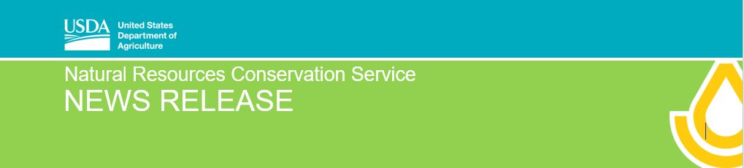
For Immediate Release: March 13, 2020 Contact: Paige.buck@usda.gov 217-353-6606

Get Signed up for Wetland Reserve Easements
Champaign, IL, March 13, 2020—Ivan Dozier, State Conservationist, announced the application period for the 2020 Agricultural Conservation Easement Program (ACEP-WRE). USDA’s Natural Resources Conservation Service (NRCS) helps provide long-term protection of Illinois’ farmland, wetlands and grasslands through ACEP. “The first application cut-off date has been established,” Dozier explains. “Right now we’re accepting applications for Wetland Reserve Easements (WRE). Applications that meet program eligibility and ranking criteria and are received by April 13th will be considered for the 2020 program.”
For ACEP-WRE in FY20, Illinois was allocated $5.4 million. NRCS may establish a second application funding cutoff opportunity later this year if all funds are not used in the first application cutoff. Dozier reminds farmers and landowners they can apply for ACEP—and all conservation programs—at any time, as sign-up is continual and applications can be submitted any time.
NRCS offers two types of easements through ACEP: Agricultural Land Easements (ALE) and Wetland Reserve Easements (WRE). NRCS will establish an application cutoff for ALE at a later date. NRCS is still finalizing ranking criteria for fiscal year 2020. The Geographic Area Rate Caps (GARCs) have been established and are available on the NRCS website. GARCs establish the rate per acre that NRCS pays to landowners for the ACEP-WRE easement.
The purpose of the Wetland Reserve Easements (WRE) is to help landowners enhance and protect habitat for wetland wildlife on their lands, reduce impacts from flooding, recharge groundwater, provide outdoor recreation, and increase habitat for migratory waterfowl.
NRCS provides technical and financial assistance directly to private landowners to restore, protect and enhance wetlands through the purchase of these easements, and eligible landowners can choose to enroll in a permanent or 30-year easement. To apply for a wetlands easement through ACEP - WRE, visit NRCS at your local USDA Service Center.
Find more information about ACEP and other NRCS conservation programs in Illinois online at www.il.nrcs.usda.gov/programs.

###
USDA is an equal opportunity provider, employer and lender.

